Benjamin Davis
Bcd0012@uah.edu
Abstract
Agile is a very common industry software development methodology. However, its often that the procedures used in the standard have time waste. Additionally, the teams do not leverage the ceremonies well to improve their performance. I would like to explore the team interactions through these ceremonies and identify trends - applying the previous research using semantic analysis – to discover ways to improve software team efficiencies.
CS699 Tse proposal
Team Situational Awareness in Agile

- Abstract
  - Agile is a very common industry software development methodology. However, its often that the procedures used in the standard have time waste. Additionally, the teams do not leverage the ceremonies well to improve their performance. I would like to explore the team interactions through these ceremonies and identify trends - applying the previous research using semantic analysis – to discover ways to improve software team efficiencies.
- Introduction
  - Below is documentation of the key points in the agile process with definition and examples of how they relate to the team dynamics and the purpose they serve. This content should assist in developing the next steps for data collection.
  - Agile Ceremonies methods and examples
    - Daily Scrum – The Daily Scrum is a short (<15 minutes) tag up meeting for the team to plan for the day’s work. In this meeting each member is meant to provide three items (1 – What they did yesterday, 2 – What they are doing today, 3 – What (If any) blockers do they have)
    - Retrospective – The Retrospective takes place after the conclusion of the sprint before the start of the next sprint and allows the team to discuss and refine their processes as a team. The team is meant to address what went well during the sprint and what could go better in the next sprint.
    - Planning – The Planning meeting is where the team brings in the work they plan to accomplish during the Sprint. The team is meant to be self-organized and so work is not assigned but rather the team volunteers for the work they are going to accomplish.
    - Backlog Refinement – Backlog Refinement is sometimes only done with the product owner to define and refine work that needs to be done on the product. This is an opportunity to address the size of tasks, scope of work, and define the acceptance criteria of tasks.
  - Team Size
    - Agile standards – the scrum alliance state that the recommended team size is between 3 and 9 individuals. Other sources place the optimal size as 7 individuals plus or minus 3
    - Sources
      - https://resources.scrumalliance.org/Article/scrum-team
      - https://teamhood.com/agile/scrum-team-size/
      - https://teamhood.com/agile/scrum-team-size/
  - Team Performance and communication.
    - Agile Metrics – Agile has a wide range of metrics you can collect to draw conclusions about team performance and potential areas where the team can improve.
      - Velocity – Team Velocity shows the amount of points a team completes in a sprint.

      - Burndown – The Burndown for a team is a representation of the rate at which tasks are completed over time. You can see from the attached example how the tasks are accomplished iteratively and are not meant to always to take the entire sprint.
      - 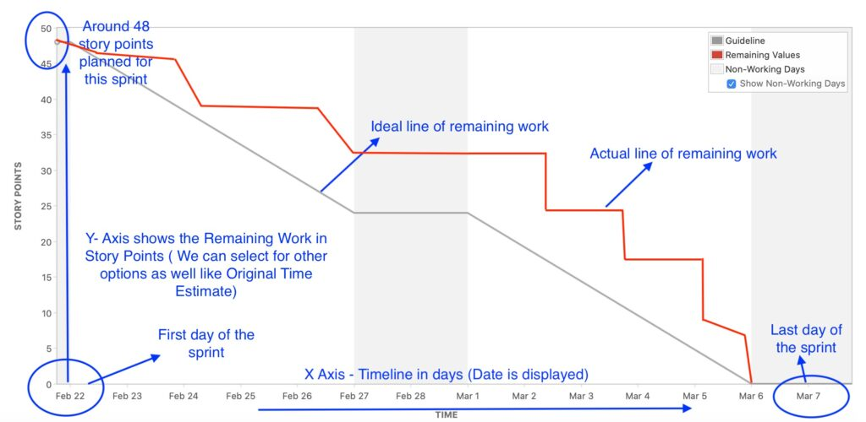
Figure 1 - Jira Burndown Chart
      - Throughput – Throughput represents the rate at which tasks are completed or the number of tasks completed in a sprint.
      - Blocked time – Blocked time is the amount of time that a task is hindered in its progress due to an outside factor (Development environment is down, unexpected task dependency, etc)
      - Sources: https://managementbliss.com/how-to-read-burndown-charts-in-jira/
- Conclusion
3.1 Leveraging above understanding of agile and software engineering. I need assistance in identifying areas where this data can be gathered and how it can be applied to the use case of Team Situational Awareness. I need to know how to create a simulation to encourage uniform results from teams. Or how I could collaborate with industry professionals to gather real-world data for this research.

